

CARBON REDUCTION PLAN GUIDANCE

Notes for Completion

Where an In-Scope Organisation has determined that the measure applies to the procurement, suppliers wishing to bid for that contract are required at the selection stage to submit a Carbon Reduction Plan which details their organisational carbon footprint and confirms their commitment to achieving Net Zero by 2050.

Carbon Reduction Plans are to be completed by the bidding supplier entity and must meet the reporting requirements set out in supporting guidance, and include the supplier’s current carbon footprint and its commitment to reducing emissions to achieve Net Zero emissions by
2050.

The Carbon Reduction Plan should be updated regularly (at least annually) and published and clearly signposted on the supplier’s UK website. It should be approved by a director (or equivalent senior leadership) within the supplier’s organisation to demonstrate a clear commitment to emissions reduction at the highest level. Suppliers may wish to adopt the key objectives of the Carbon Reduction Plan within their strategic plans.

A template for the Carbon Reduction Plan is set out below. Please complete and publish your Carbon Reduction Plan in accordance with the reporting standard published alongside this PPN.

Carbon Reduction Plan

Supplier name: ERH

Publication date: 30/09/2025

Commitment to achieving Net Zero

ERH is committed to achieving Net Zero emissions by 2050.

Baseline Emissions Footprint

Baseline emissions are a record of the greenhouse gases that have been produced in the past and were produced prior to the introduction of any strategies to reduce emissions. Baseline emissions are the reference point against which emissions reduction can be measured.

Baseline Year: 2024-25
Additional Details relating to the Baseline Emissions calculations:
In previous years we had reported our carbon emissions as a group, however we have recently implemented improvements to our reporting processes which has enabled us to improve the accuracy and increase the level of detail in the data collected. As a result of these improvements, we are able to report for each business within the Centregreat group on an individual basis. This 2024- 2025 carbon reduction plan will act as our new baseline year, in which we will measure ourselves against going forward.

Baseline year emissions:
EMISSIONS | TOTAL (tCO2e)
Scope 1 | 651.70
Scope 2 | 0.978
Scope 3  (Included  Sources) | 159.48  (Fuel & Energy related activities, , waste generated, water, business travel,
Total Emissions | 812.16

Current Emissions Reporting

Reporting Year: 2024/2025
EMISSIONS | TOTAL (tCO2e)
Scope 1 | 651.70
Scope 2 | 0.978
Scope 3  (Included  Sources) | 159.48  (Fuel & Energy related activities, , waste generated, water, business travel,
Total Emissions | 812.16

Emissions Reduction Targets
In order to continue our progress to achieving Net Zero, we have adopted the following carbon reduction targets:

- Increase electrification of fleet to 5% year on year to 2030. Complete car fleet fully electric by 2030.
- Use of electric excavator,
- Replacement of existing energy suppliers to Sustainable energy only by end of 2026.
4. Roll out phased introduction of HVO fuel as a true drop-in alternative to diesel in plant. Plant 25% HVO by end of 2025, 60% by end of 2026, full HVO by end of 2027.
5. Increase local generation in addition to two current solar PV arrays (initial investment 2012). Introduce solar PV at Hayes facility in Cardiff and our Brackla Head Office, to offset emissions from electricity usage to circa net zero (ambition to achieve net positive generation). Timeline – installation complete by 2028.
6. Continued asset renewal investment to drive efficiency of fleet. Identify new an alternative equipment that not only reduces consumption in use, but also provides opportunities to decrease idling for vehicle mounted equipment to function. Target 25% reduction in fuel use by 2027.

We project that carbon emissions will decrease over the next five years to
650tCO2e by 2030.
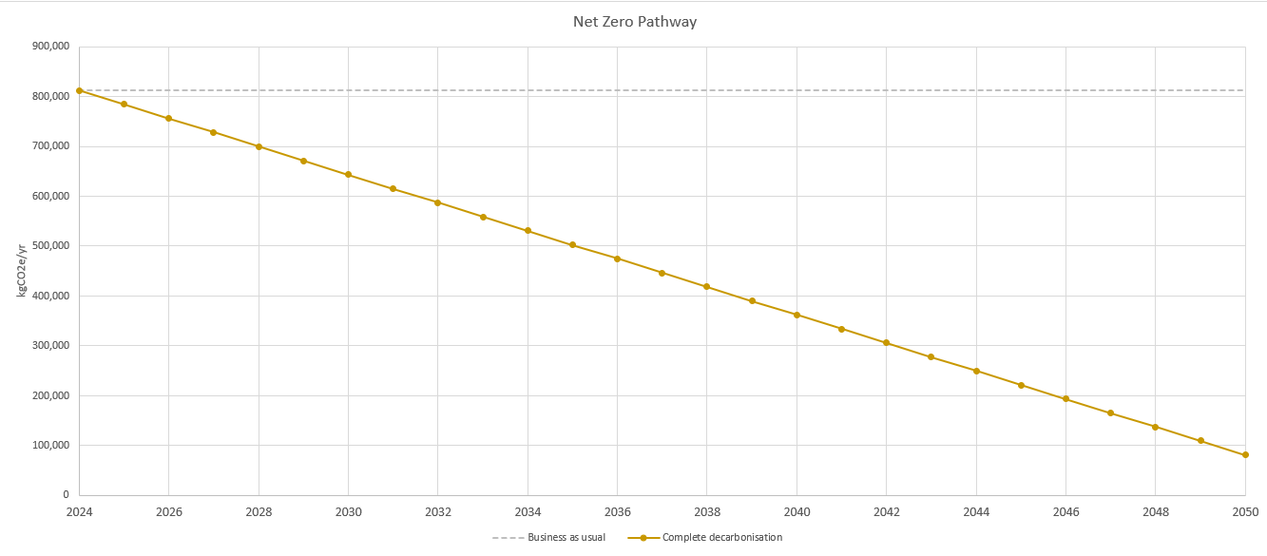

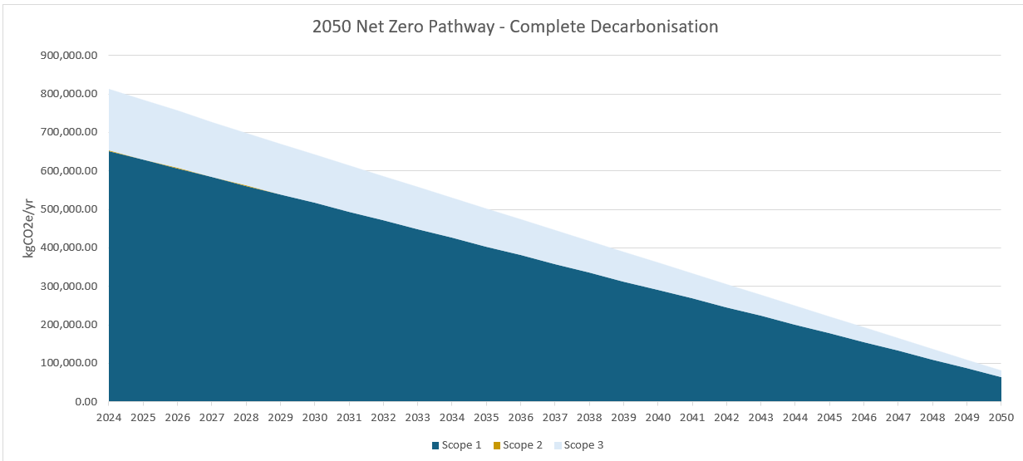
Carbon Reduction Projects

The following environmental management measures and projects have been completed or implemented since 2024. The carbon emission reduction achieved by these schemes are not measurable at this point as there is a lot of the initiatives are recent, so should be recognised in the next reporting period. At that point we will report the tCO2e reduction and %ge reduction against the 2024-2025 baseline and the measures will be in effect when performing the contract. Measures that have been put in place include:

1. Maintaining accreditation to ISO 14001

2. Increase of EVs into our fleet, both company cars and site vehicles, for maintenance. A thorough trial period was undertaken to select the most appropriate EV van, with careful consideration of which operations this is best suited to for effective operation.

3. Introduction of EV chargers at 3x depot locations; installed by our in-house team.

4. Upgrading of our owned vehicle fleet on an ongoing basis to Euro 6 compliant as a minimum.

5. Investment in innovative plant to reduce carbon associated with traditional work practices, e.g. JBC Pothole Pro for carriageway repairs - effecting preparation and repair with one machine, Vacuum excavators - reducing carbon associated with traditional dig methods and diesel powered tools.

6. Roll out of Confirm:Workzone works management software to allocate carriageway repair works to mobile teams in the most efficient manner. Potential to extend these benefits to our other maintenance contracts.

7. Utilisation of AI to improve business efficiency and carbon outputs.

8. Investment in renewable, on-site energy generation through solar PV at our depots.

9. Cross business rollout of Microsoft Office 365, maximising the benefits of online collaboration to remove unnecessary business travel.

10. Upgrading of our Head Office, including re-cladding and installation of energy saving LED lighting throughout the depot and workshop spaces.

11. No-idling policy.

12. Use of Hybrid Generators on sites resulting in a reduction of 40,000 KgCo2 based on a 20 week programme.

In the future we hope to implement further measures such as:
1. Maintaining accreditation to ISO 14001.

2. Grow the numbers of EVs within our fleet, both company cars and site vehicles.

3. Trial use of HVO within our plant and investigate other cleaner fuel alternatives, such as hydrogen.

4. Extend EV charging provision at depots – Availability to clients and visitors as well as our own staff.

5. Maximising energy supply from renewable sources.

6. Increase on-site electrical generation, utilising the extensive roof space of our depots.

Declaration and Sign Off

This Carbon Reduction Plan has been completed in accordance with PPN 06/21 and associated guidance and reporting standard for Carbon Reduction Plans.

Emissions have been reported and recorded in accordance with the published reporting standard for Carbon Reduction Plans and the GHG Reporting Protocol corporate standard1 and uses the appropriate Government emission conversion factors for greenhouse gas company reporting2.

Scope 1 and Scope 2 emissions have been reported in accordance with SECR requirements, and the required subset of Scope 3 emissions have been reported in accordance with the published reporting standard for Carbon Reduction Plans and the Corporate Value Chain (Scope 3) Standard3.

This Carbon Reduction Plan has been reviewed and signed off by the board of directors (or equivalent management body).


Signed on behalf of the Supplier:

…………………………………………………………………. Date: …………30/09/2025….……….

1 https://ghgprotocol.org/corporate-standard
2 https://www.gov.uk/government/collections/government-conversion-factors-for-company-reporting
3 https://ghgprotocol.org/standards/scope-3-standard

